**Appendix B**

As described in the manuscript, the identification of the challenges hindering the adoption of Machine Learning (ML) for Predictive Maintenance (PdM) was done through a Systematic Literature Review (SLR) and a Delphi Study. This appendix describes in detail the conducted SLR (the key concepts can be found also in the manuscript).

Following the literature (Peron et al., 2024; Saihi et al., 2022), the SLR was considered as a valid approach to identify potential challenges associated with the adoption of ML for PdM reported by scholars. Indeed, the SLR assures replicability, validity, and reliability of the results (Sudusinghe and Seuring, 2022). Specifically, in this work the three-steps approach proposed by Tranfield et al. (2003) was chosen as SLR methodology.

*Step 1 - Planning the review*

During the first step of the SLR, the need and the protocol of the SLR were determined. While the need for this study was described above, the protocol adopted in this study is the PRISMA protocol developed by Moher et al. (2010) and adopted in many other SLRs (Ahi and Searcy, 2015; Amrutha and Geetha, 2020; Loureiro et al., 2021; Mancusi et al., 2024; Peron et al., 2022).

*Step 2 - Conducting the review*

The second step of the SLR was performed following the PRISMA protocol and using Scopus as database due to its wide coverage of relevant journals (Ahi and Searcy, 2015). The search adopted a two-groups keywords structure with the keywords adopted listed in Table B1. Group A contains keywords related to PdM and the related Condition-Based Maintenance (CBM). Notably, CBM is also included among the keywords since PdM can be considered as a sub-group of CBM policies, and they are sometimes used interchangeably (Prajapati et al., 2012). Group B, then, is composed of keywords associated with ML and other relevant algorithms. Notably, in this work we refer to the generic concept of ML which includes different types of sub-categories, such as deep learning, transfer learning, etc. The keywords of each group were combined through the logical operator “OR”, while the logical operator “AND” was used to link the two groups.

**Table B1:** Keywords adopted for the SLR

|  |  |
| --- | --- |
| **Group A** | **Group B** |
| “Predictive Maintenance”  “Condition-Based Maintenance”  “Condition Based Maintenance”  “Condition Monitor*”  “Prognostic Maintenance”  “Proactive Maintenance” | “Machine Learning”  “Deep Learning”  “Transfer Learning”  “Reinforcement Learning” |

The research string so defined was searched within Title, Abstract, and Keywords of the documents. The search was limited to only documents written in English up to 2023, falling in the following areas: “Engineering”, “Decision Sciences”, “Business, Management, and Accounting”, and “Computer science”. This led to the identification of 4274 documents (January 2024). The following inclusion criteria were also considered:

1. Type of document: only reviews. This is aligned with the objectives of the current SLR since it aims to solely identify from the literature a comprehensive list of challenges. Notably, as discussed in the introduction, many reviews focusing on the challenges associated with the adoption of ML for PdM exist, and hence we limited the analysis to these.
2. Quality of document: only reviews published in journals with Scientific Journal Ranking (SJR) higher than one were considered. This is useful to ensure high quality of the output, as previously done by other works (Dolgui et al., 2022; Peron et al., 2024).
3. Accessibility: only documents with full text availability were considered.
4. Detailed focus: only documents explicitly related to ML for PdM were considered. Moreover, given the scope of this work, only documents related to industrial plants were considered. For instance, documents related to civil engineering were excluded. Finally, only documents mentioning challenges that hinder the adoption of ML for PdM were considered.

Notably, following the suggestions from the literature (Seuring and Gold, 2012), (iv) was performed by two distinct authors to assure a high level of reliability and reduce the subjectivity. This resulted in a total of 67 documents. Finally, the same two authors performed full text screening of these documents to confirm their relevance, resulting in a total of 29 documents. The document selection process is schematically summarized in Figure B1.

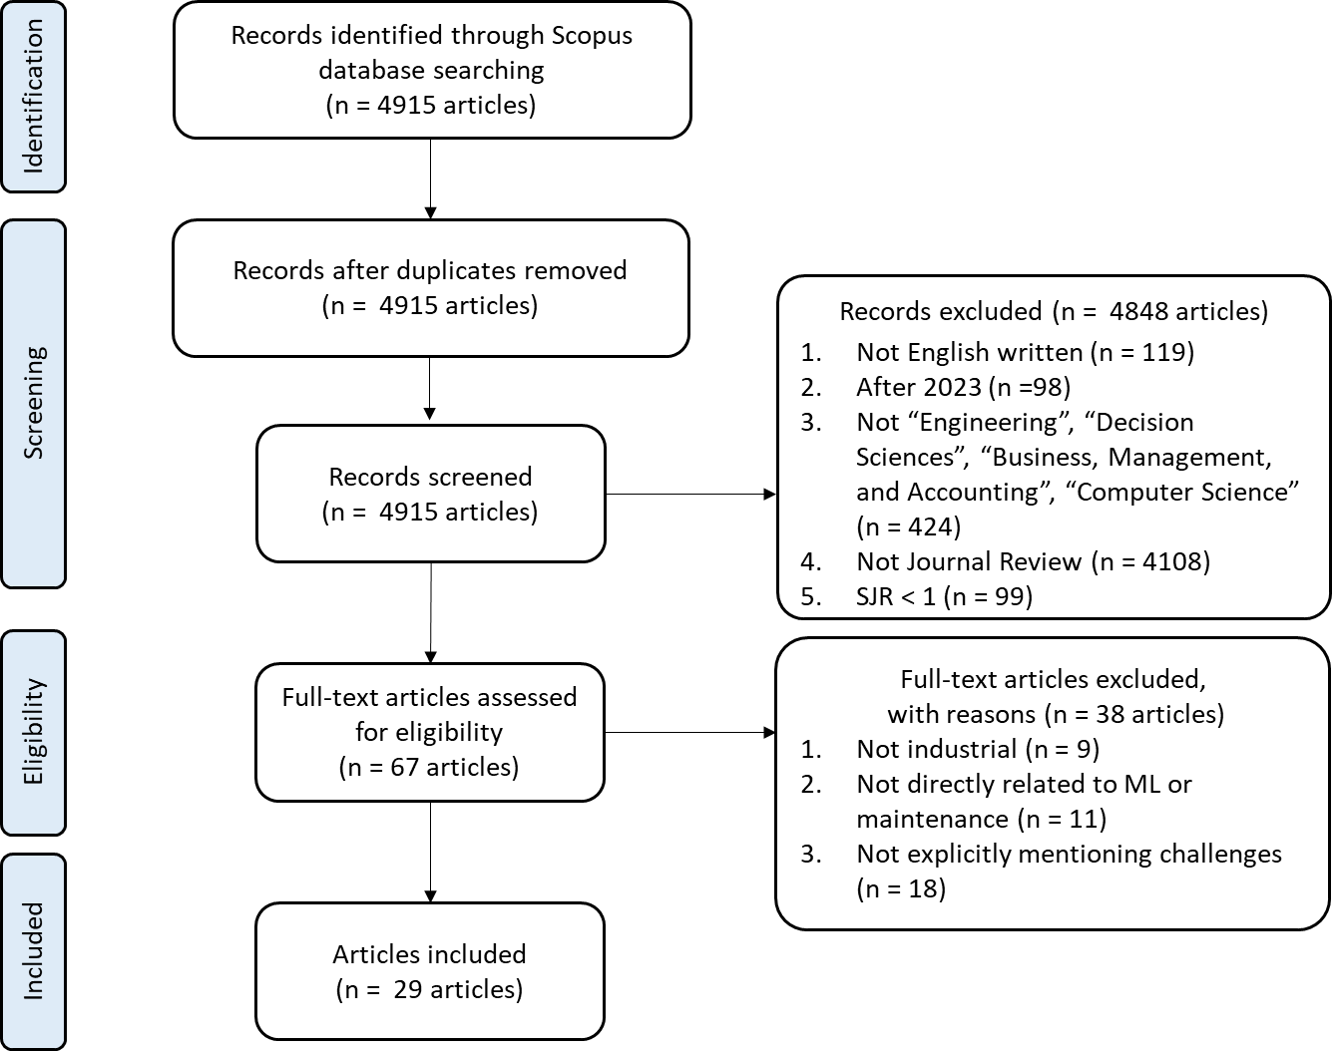

**Figure 2**: PRISMA scheme of the conducted SLR

*Step 3 – Reporting and dissemination*

Finally, the third step of the SLR is carried out. Notably, given the aim of this work, the descriptive analysis was not performed. The ‘reporting and dissemination’ step, hence, consisted only of the content analysis of the 29 remaining documents, from which it was possible to identify the challenges hindering the adoption of ML for PdM and to define the corresponding propositions to be used in the Delphi study. Notably, Appendix D reports for each of the 29 papers which are the discussed challenges.

**References**

Ahi, P., Searcy, C., 2015. Measuring social issues in sustainable supply chains. Measuring Business Excellence 19, 33–45.

Amrutha, V.N., Geetha, S.N., 2020. A systematic review on green human resource management: Implications for social sustainability. Journal of Cleaner production 247, 119131.

Dolgui, A., Sgarbossa, F., Simonetto, M., 2022. Design and management of assembly systems 4.0: systematic literature review and research agenda. International Journal of Production Research 60, 184–210. https://doi.org/10.1080/00207543.2021.1990433

Loureiro, S.M.C., Guerreiro, J., Tussyadiah, I., 2021. Artificial intelligence in business: State of the art and future research agenda. Journal of business research 129, 911–926.

Mancusi, F., Fruggiero, F., Pham, D.T., 2024. The Remanu-Leasing Model Towards a Convenient and Sustainable Product Circularity, in: Fera, M., Caterino, M., Macchiaroli, R., Pham, D.T. (Eds.), Advances in Remanufacturing, Lecture Notes in Mechanical Engineering. Springer Nature Switzerland, Cham, pp. 377–387. https://doi.org/10.1007/978-3-031-52649-7_30

Moher, D., Liberati, A., Tetzlaff, J., Altman, D.G., Group, P., 2010. Preferred reporting items for systematic reviews and meta-analyses: the PRISMA statement. International journal of surgery 8, 336–341.

Peron, M., Arena, S., Micheli, G.J.L., Sgarbossa, F., 2022. A decision support system for designing win–win interventions impacting occupational safety and operational performance in ageing workforce contexts. Safety science 147, 105598.

Peron, M., Saporiti, N., Shoeibi, M., Holmström, J., Salmi, M., 2024. Additive manufacturing in the medical sector: from an empirical investigation of challenges and opportunities toward the design of an ecosystem model. International Journal of Operations & Production Management.

Prajapati, A., Bechtel, J., Ganesan, S., 2012. Condition based maintenance: a survey. Journal of Quality in Maintenance Engineering 18, 384–400.

Saihi, A., Ben-Daya, M., As’ ad, R., 2022. Underpinning success factors of maintenance digital transformation: A hybrid reactive Delphi approach. International Journal of Production Economics 108701.

Seuring, S., Gold, S., 2012. Conducting content-analysis based literature reviews in supply chain management. Supply Chain Management: An International Journal 17, 544–555.

Sudusinghe, J.I., Seuring, S., 2022. Supply chain collaboration and sustainability performance in circular economy: A systematic literature review. International Journal of Production Economics 245, 108402.

Tranfield, D., Denyer, D., Smart, P., 2003. Towards a Methodology for Developing Evidence‐Informed Management Knowledge by Means of Systematic Review. British J of Management 14, 207–222. https://doi.org/10.1111/1467-8551.00375